INTRODUCTION
Industrial CNC (Computer Numerical Control) milling machines are widely used in modern manufacturing industries for producing high-precision components with improved speed, accuracy, consistency, and automation. These machines play an important role in industrial production, where continuous operation and reliability are essential. However, unexpected machine failures can lead to unplanned production downtime, increased maintenance costs, reduced productivity, equipment damage, and financial losses. Traditional maintenance approaches, such as reactive maintenance and periodic maintenance, may not always detect failures at the right time. Therefore, predictive maintenance has emerged as an important approach that uses machine operating data and advanced analytical techniques to identify potential failures before they become critical.
This project proposes a Machine Learning-Based Predictive Maintenance System for industrial CNC milling machines using machine operating parameters and sensor data. The system is designed not only to predict whether a machine is likely to fail but also to identify the possible type of failure when a failure is detected. The machine operating parameters used for analysis include air temperature, process temperature, rotational speed, torque, and tool wear. The study performs data preprocessing and exploratory data analysis to understand the characteristics of the dataset, including missing values, duplicate records, outliers, feature relationships, and class imbalance. Data visualization techniques such as histograms, box plots, bivariate analysis, and correlation matrices are used to identify important patterns and relationships among machine parameters. Machine Learning algorithms, including Random Forest, Support Vector Machine (SVM), and XGBoost, are used to develop predictive models for machine failure prediction. The models are evaluated using performance metrics such as Accuracy, Precision, Recall, F1-Score, ROC-AUC Score, and Confusion Matrix to determine the most effective model for predicting potential machine failures.
The selected predictive models are integrated into a Flask-based web application connected to a MySQL database, providing an interactive platform for managing machine data and prediction records. Users can enter machine operating values, perform failure predictions, identify possible failure types, view prediction history, and access machine-related information through the application dashboard. The system also provides maintenance recommendations based on the predicted machine condition and helps highlight machines that require attention. By supporting early fault detection and data-driven maintenance decision-making, the proposed system can help reduce unexpected machine downtime, minimize maintenance costs, improve equipment reliability, and enhance the overall efficiency and productivity of industrial CNC milling machine operations.

SUPPORTING LITERATURE

Literature Review

Paper 1 - Burmeister N., Frederiksen R. D., Høg E., & Nielsen P. Exploration of Production Data for Predictive Maintenance of Industrial Equipment: A Case Study. IEEE Access, 2023.
The paper titled “Exploration of Production Data for Predictive Maintenance of Industrial Equipment: A Case Study” investigates the use of production-stage data for predictive maintenance instead of relying on real-time sensor data. The study utilizes interpretable machine learning models, namely Bayesian Networks (BN) and Classification Trees (CT), to predict future equipment failures using 227,996 production and inspection records collected over five years. The dataset undergoes preprocessing techniques such as missing value imputation, feature selection, class balancing, and probability calibration. The models are evaluated using rolling-window cross-validation and performance metrics including Accuracy, ROC-AUC, F1-Score, Sensitivity, and Specificity. Among the evaluated models, the Classification Tree with Random Undersampling (CT-RUS) achieved the highest accuracy of 89.0%, demonstrating that interpretable machine learning models can effectively support predictive maintenance, improve maintenance planning, reduce equipment downtime, and lower maintenance costs.
TITLE | Exploration of Production Data for Predictive Maintenance of Industrial Equipment: A Case Study
AREA OF WORK | Develops an interpretable machine learning framework for pre-dictive maintenance using production-stage data to identify de-fects early, reduce maintenance costs, minimize downtime, and improve equipment reliability.
DATASET | Industrial dataset from a European manufacturing company containing 227,996 records and 29 features with numerical, categorical, and time-based variables.
METHODOLOGY/ STRATEGY | Data preprocessing, feature selection, class balancing, and training of Bayesian Networks and Classification Trees using rolling-window cross-validation. Performance evaluated with Accuracy, F1-Score, ROC-AUC, PR-AUC, and Brier Score.
ALGORITHM | Bayesian Networks, Classification Trees, Mutual Information Feature Selection, Random Over/Under Sampling, Platt Scaling.
RESULT / PRECISION | CT-RUS achieved the best performance with 89.0% accuracy,  providing accurate and interpretable maintenance predictions.
ADVANTAGES | Enables early defect detection, reduces maintenance costs and downtime, improves reliability, and provides transparent decision-making.
FUTURE PROPOSAL | Validate the framework on more industrial datasets and explore additional interpretable machine learning techniques to improve performance.
Table 2.1: Summary of Paper 1

Paper 2 – Leite H., Leite D., & Rativa D. Early Fault Detection and Diagnosis in Industrial

Machines: An Approach Using Digital Twins. IEEE Access. 2026.
The paper titled “Early Fault Detection and Diagnosis in Industrial Machines: An Approach Using Digital Twins” presents a predictive maintenance framework that integrates Digital Twin (DT) technology with Machine Learning (ML) for real-time fault detection and diagnosis. The proposed approach combines Digital Twin-generated residual features with machine operating data and evaluates 16 machine learning algorithms, including Random Forest, Decision Tree, Support Vector Machine (SVM), Logistic Regression, Gradient Boosting, and LightGBM. The framework was validated using simulated Pick-and-Place and Furnace industrial systems, with Bayesian optimization and 10-fold cross-validation applied for model optimization. Experimental results demonstrated significant improvements in prediction performance, achieving 91% F1-Score for the Pick-and-Place system, 100% F1-Score for intra-cycle fault detection, and 98% F1-Score for the Furnace system while detecting faults approximately 40% earlier than conventional machine learning approaches.
The study concludes that integrating Digital Twin technology with machine learning enables accurate, reliable, and timely fault detection, making it an effective solution for real-time predictive maintenance.
TITLE | Early Fault Detection and Diagnosis in Industrial Machines: An Approach Using Digital Twins
AREA OF WORK | Develops a Digital Twin and Machine Learning-based framework for real-time fault detection to improve predictive maintenance, reduce downtime, and increase equipment reliability.
DATASET | Simulated datasets from Pick-and-Place and Furnace industrial systems containing real-time process data and Digital Twin residual features.
METHODOLOGY / STRATEGY | Combines Digital Twin residuals with sensor data to train machine learning models. Uses inter-cycle and intra-cycle fault detection, Bayesian optimization, and 10-fold cross-validation.
ALGORITHM | Random Forest, Decision Tree, SVM, Logistic Regression, KNN, Naïve Bayes, AdaBoost, Gradient Boosting, Extra Trees, LightGBM, and MLP.
RESULT / PRECISION | Achieved a 91% F1-Score for inter-cycle and 100% F1-Score for intra-cycle fault detection in the Pick-and-Place machine, and a 98% F1-Score with 40% earlier fault detection for the Furnace system.
ADVANTAGES | Improves early fault detection, diagnostic accuracy, equipment reliability, and supports efficient real-time predictive maintenance.
FUTURE PROPOSAL | Validate the framework on real industrial systems, develop advanced Digital Twins, and extend the framework to handle multiple fault scenarios.
Table 2.2: Summary of Paper 2

Paper 3 – Akyaz T., & Engin D. Machine Learning-Based Predictive Maintenance System for

Artificial Yarn Machines. IEEE Access. 2024.
The paper titled “Machine Learning-Based Predictive Maintenance System for Artificial Yarn Machines” presents an IoT-enabled predictive maintenance framework that integrates Machine Learning and Deep Learning techniques to improve the reliability of artificial yarn production machines. The system utilizes multiple sensors connected to an ESP32 microcontroller to collect machine operating parameters, including vibration, motor body temperature, motor winding temperature, gearbox temperature, and energy consumption. The collected data are transmitted to the ThingSpeak cloud platform for storage, preprocessing, and real-time monitoring. Five predictive models—Random Forest (RF), Support Vector Regression (SVR), Decision Tree (DT), Gaussian Process Regression (GPR), and Deep Neural Network (DNN)—were evaluated. Experimental results showed that the Deep Neural Network achieved the best performance with 96% prediction accuracy and an 86% validation score, outperforming the traditional machine learning models. The study concludes that integrating IoT with machine learning enables effective real-time predictive maintenance by supporting early fault detection, reducing machine downtime, lowering maintenance costs, and improving overall operational efficiency.
TITLE | Machine Learning-Based Predictive Maintenance System for Artificial Yarn Machines
AREA OF WORK | The paper proposes an IoT-enabled predictive maintenance system using Machine Learning and Deep Learning for early fault detection, reducing downtime and improving machine reliability.
DATASET | A real-time industrial dataset collected from an IoT-enabled artificial yarn production (BCF) machine, containing operational parameters such as vibration, motor temperature, gearbox temperature, and energy consumption over one year.
METHODOLOGY / STRATEGY | IoT sensor data were collected, preprocessed, and used to train multiple ML and DL models. The models were deployed on ThingSpeak for real-time machine monitoring and fault detection.
ALGORITHM | Random Forest (RF), Support Vector Regression (SVR), Decision Tree (DT), Gaussian Process Regression (GPR), and Deep Neural Network (DNN).
RESULT / PRECISION | The Deep Neural Network (DNN) achieved the highest performance with 96% accuracy and an 86% validation score, enabling early fault detection and reducing machine downtime.
ADVANTAGES | Provides real-time machine monitoring, early fault detection, reduced downtime, lower maintenance costs, and improved operational efficiency.
FUTURE PROPOSAL | Extend the framework to other industrial machines, use larger datasets, integrate additional sensors, and enhance real-time cloud monitoring.
Table 2.3: Summary of Paper 3

Literature Review Summary
TITLE | SUMMARY
Burmeister N., Frederiksen R. D., Høg E., & Nielsen P. Exploration of Production Data for Predictive Maintenance of Industrial Equipment: A Case Study. IEEE Access. 2023. | This study uses production-stage data and interpretable machine learning models to predict equipment failures. The Classification Tree model achieved the highest accuracy of 89.0%, supporting accurate and transparent predictive maintenance.
Leite H., Leite D., & Rativa D. Early Fault Detection and Diagnosis in Industrial Machines: An Approach Using Digital Twins. IEEE Access. 2026. | This study proposes a Digital Twin-based predictive maintenance framework that combines Digital Twin features with machine learning for real-time fault detection. The system achieved up to 100% F1-Score and detected faults 40% earlier than conventional methods.
Akyaz T., & Engin D. Machine Learning-Based Predictive Maintenance System for Artificial Yarn Machines. IEEE Access. 2024. | This study proposes an IoT-enabled predictive maintenance system using Machine Learning and Deep Learning for early fault detection. The Deep Learning model achieved the highest accuracy of 96%, reducing machine downtime and maintenance costs.
Table 2.4: Overall Summary of all paper

Findings and Proposals
The study by Burmeister et al. (2023) demonstrated that interpretable machine learning models, particularly Classification Trees, can accurately predict equipment failures using production-stage data while supporting transparent maintenance decisions. Leite et al. (2026) proposed a Digital Twin-based framework that improved real-time fault detection by integrating Digital Twin features with machine learning algorithms. Akyaz and Engin (2024) developed an IoT-enabled predictive maintenance system in which a Deep Learning model achieved 96% accuracy, enabling early fault detection and reducing machine downtime.
Based on these findings, the proposed work develops a Predictive Maintenance System for Industrial CNC Milling Machines using Random Forest, Support Vector Machine (SVM), and XGBoost algorithms. The models are evaluated using Accuracy, Precision, Recall, F1-Score, ROC-AUC, and Confusion Matrix. The best-performing model is deployed as a Flask-based web application integrated with a MySQL database to provide machine failure prediction, likely failure type identification, maintenance recommendations, prediction history, and machine health visualization.

Problem Statement
Industrial CNC milling machines are essential for modern manufacturing industries, where unexpected machine failures can lead to production delays, increased maintenance costs, reduced productivity, and equipment damage. Traditional maintenance approaches, such as reactive and preventive maintenance, often fail to identify faults before they occur, resulting in unplanned downtime. Although recent machine learning-based predictive maintenance systems have improved fault prediction accuracy, many existing approaches either depend on specialized IoT infrastructure or Digital Twin technology, which can increase implementation complexity and cost. Consequently, there is a need for a predictive maintenance system that can accurately predict machine failures, identify likely failure types, and support timely maintenance decision-making using machine learning techniques.

Motivation
The increasing adoption of Industry 4.0 technologies has created a growing demand for intelligent predictive maintenance solutions that improve machine reliability and reduce operational costs. The motivation behind this project is to develop a machine learning-based predictive maintenance system capable of predicting machine failures at an early-stage using historical machine operating data. The proposed system aims to provide accurate machine failure predictions, identify likely failure types, and support better maintenance planning through timely maintenance recommendations. This can help reduce unexpected machine downtime, improve operational efficiency, and contribute to increased equipment reliability in industrial environments.

Research Gap
The literature review indicates that many existing predictive maintenance systems primarily focus on improving prediction accuracy and early fault detection. In addition, several existing approaches depend on specialized infrastructure such as IoT systems or Digital Twin technology, which may increase implementation complexity and cost. Many systems also focus mainly on failure prediction without providing maintenance recommendations, prediction history, machine health visualization, or an easy-to-use deployment platform. To address these gaps, the proposed system integrates machine learning algorithms for machine failure prediction and likely failure type identification with maintenance recommendations and a Flask-based web application integrated with a MySQL database for practical use.

SYSTEM ANALYSIS

Analysis of Dataset

About the Dataset
The project utilizes the AI4I 2020 Predictive Maintenance Dataset, obtained from the UCI Machine Learning Repository. This dataset provides a comprehensive collection of operational data from industrial machines under various working conditions for predictive maintenance research. It consists of machine identification details, operational parameters, and machine failure information, enabling the development of machine learning models for predicting machine failures and classifying different failure types. The dataset includes Identification Data, containing the Unique Identifier (UDI), Product ID, and Product Type; Machine Operational Data, including Air Temperature, Process Temperature, Rotational Speed, Torque, and Tool Wear; and Failure Data, comprising the Machine Failure label along with five specific failure types: Tool Wear Failure (TWF), Heat Dissipation Failure (HDF), Power Failure (PWF), Overstrain Failure (OSF), and Random Failure (RNF). The dataset contains 10,000 machine records with 14 attributes, has no missing values, and is well suited for developing predictive maintenance machine learning model.

Dataset sample records
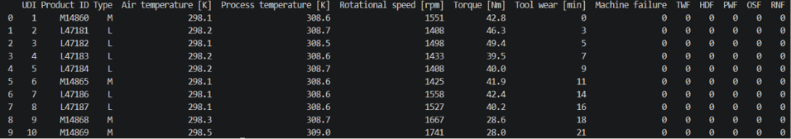
The first 10 records were displayed using the head (10) function to obtain an initial understanding of the dataset’s structure, attributes, and values. This preview helps verify the data format and provides an overview of the machine operating parameters and failure-related variables before further analysis and preprocessing.
Figure 3.1: First ten records of the dataset

Summary statistics
The describe().T function was used to generate summary statistics for the numerical features in the dataset. It provides the count, mean, standard deviation, minimum, maximum, and 25th, 50th, and 75th percentile values, giving an overview of the data distribution and feature ranges before further analysis and model development.

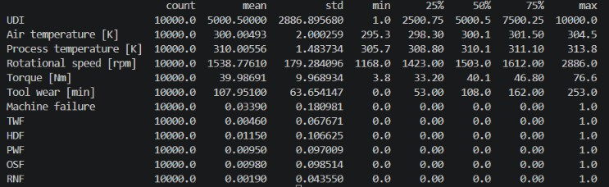
Figure 3.2: Summary Statistics of the Dataset
In Figure 3.2, the percentile values for the machine failure and individual failure-type variables are 0 because these variables are binary indicators containing only 0 and 1, and failure cases occur very rarely compared with normal operating cases. Since more than 75% of the observations have a value of 0 for these failure indicators, the 25th, 50th, and 75th percentiles remain 0. The maximum value is 1 because 1 represents the occurrence of a failure. This indicates the highly imbalanced nature of the failure-related variables in the dataset.

Explore the Dataset
The AI4I 2020 Predictive Maintenance Dataset contains 10,000 machine instances with 14 attributes, including numerical and categorical features, with no missing values. The key characteristics are:
The key characteristics observed during dataset exploration include:
- Operating Parameters: Air Temperature, Process Temperature, Rotational Speed, Torque, and Tool Wear.
- Identification Features: UDI, Product ID, and Product Type (L, M, H).
- Target Variables: Machine Failure and five failure types—Tool Wear Failure (TWF), Heat Dissipation Failure (HDF), Power Failure (PWF), Overstrain Failure (OSF), and Random Failure (RNF).
The dataset contains both numerical and categorical features with no missing values, making it suitable for preprocessing, analysis, and machine learning model development.

Data Preprocessing

Data Cleaning
      - Checking for missing values
The dataset was examined for missing values using the isna().sum() function to ensure data completeness before preprocessing and model development. The results indicated that no missing values were present in any of the dataset attributes, including the machine operating parameters and failure-related variables. Since all features contained complete records, no missing value imputation or removal techniques were required during the data cleaning process.
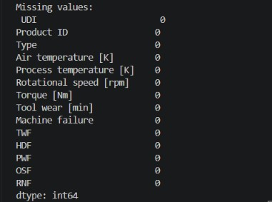
Fig 3.3 Missing values

Dropping columns
To improve the dataset for machine learning, the UDI (Unique Identifier) column was removed because it only identifies individual records and does not contribute to machine failure prediction. Product ID was retained for reference during analysis, while the remaining machine operating and failure-related attributes were retained for further preprocessing and model development.

Outlier handling
The dataset was examined for the presence of outliers using boxplots for each numerical feature. The analysis revealed that Rotational Speed and Torque contain several outliers, whereas Air Temperature, Process Temperature, and Tool Wear exhibit relatively stable distributions with few or no significant outliers. These outliers represent genuine machine operating conditions rather than erroneous measurements. Therefore, no outlier removal or transformation techniques were applied, ensuring that important operational variations relevant to machine failure prediction were preserved for subsequent analysis and model development.

Analysis of Feature Variables

Feature Selection
The AI4I 2020 Predictive Maintenance dataset contains several operational parameters that are directly related to machine health and failure prediction. During feature extraction, relevant machine operating features were selected for model development, including Air Temperature, Process Temperature, Rotational Speed, Torque, Tool Wear, and Product Type. The UDI column was removed because it serves only as a unique identifier and does not contribute to predicting machine failures. The selected features provide meaningful information about machine operating conditions and are used as input for the machine learning models to predict machine failures and identify failure types.

Categorical Feature Encoding
The Product Type feature is categorical with three categories: L (Low), M (Medium), and H (High). Since machine learning algorithms require numerical input, this feature was converted into numerical values using Label Encoding. This transformation preserves the categorical information while making the data suitable for model training.

Analysis of Class Variables
The target class variable in this project is Machine Failure, which indicates whether a machine is operating normally or has experienced a failure. In addition to the overall machine failure label, the dataset contains five specific failure categories: Tool Wear Failure (TWF), Heat Dissipation Failure (HDF), Power Failure (PWF), Overstrain Failure (OSF), and Random Failure (RNF). Analysis of the class variable revealed that the dataset is dominated by normal operating conditions, while machine failures occur relatively infrequently. This class imbalance is a common characteristic of predictive maintenance datasets and is considered during model training and evaluation to ensure reliable prediction performance.

Data Visualization

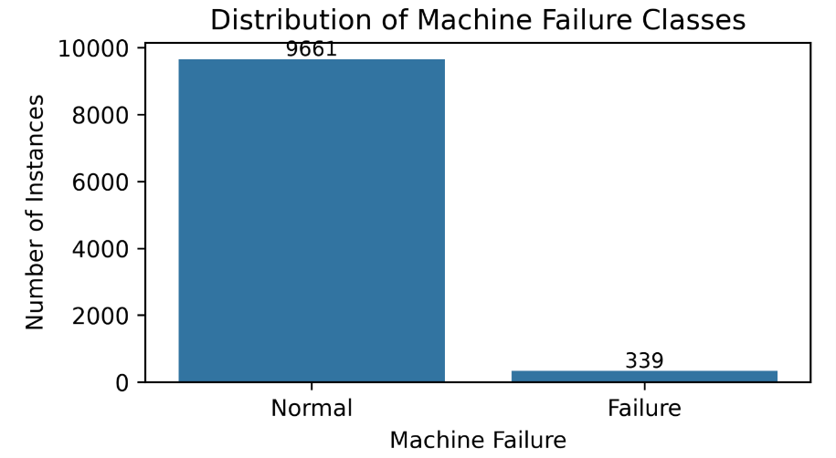
Target Class Distribution
Figure 3.4: Visualization of Target Class Distribution
Figure 3.4 shows the distribution of the target class (Machine Failure). Out of 10,000 machine instances, 9,661 are normal and 339 are failure cases. This indicates that the dataset is highly imbalanced, which is common in predictive maintenance applications where machine failures occur infrequently.

Analysis of Failure Types
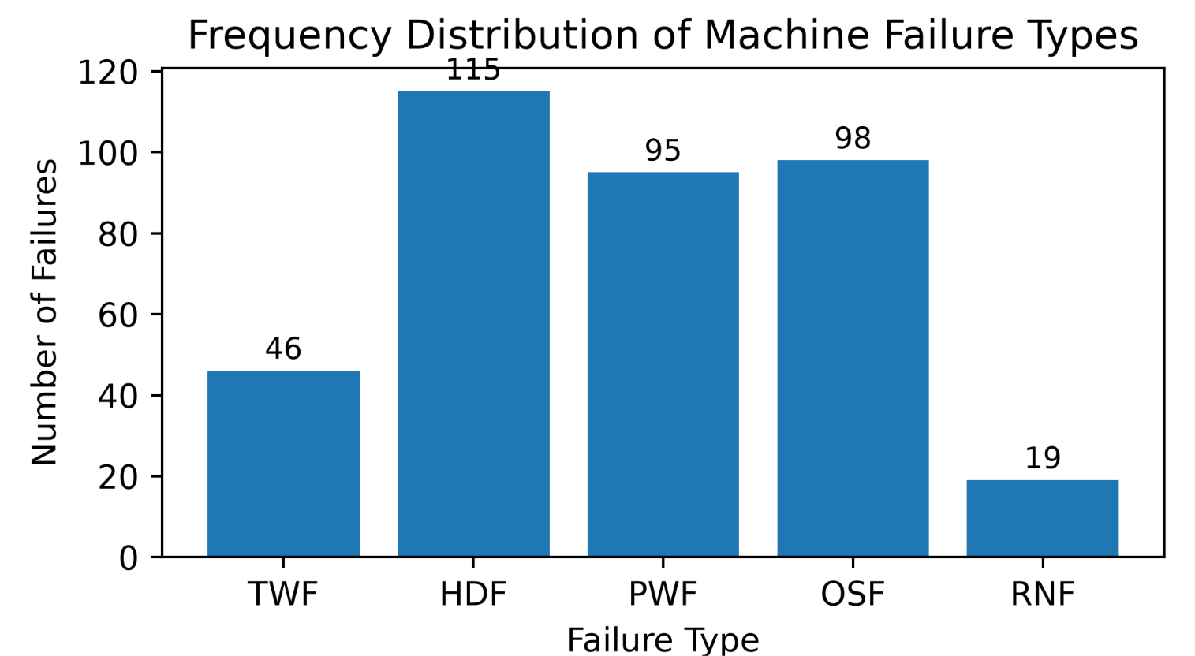
Figure 3.5: Distribution of Individual Failure Types
Figure 3.5 presents the frequency of different machine failure types in the dataset. Among the failure categories, Heat Dissipation Failure (HDF) has the highest number of instances (115), followed by Overstrain Failure (OSF) (98) and Power Failure (PWF) (95). Tool Wear Failure (TWF) accounts for 46 instances, while Random Failure (RNF) is the least frequent with 19 instances. The variation in failure frequencies indicates that certain failure types occur more frequently than others, which is useful for understanding the characteristics of machine failures and developing predictive maintenance models.

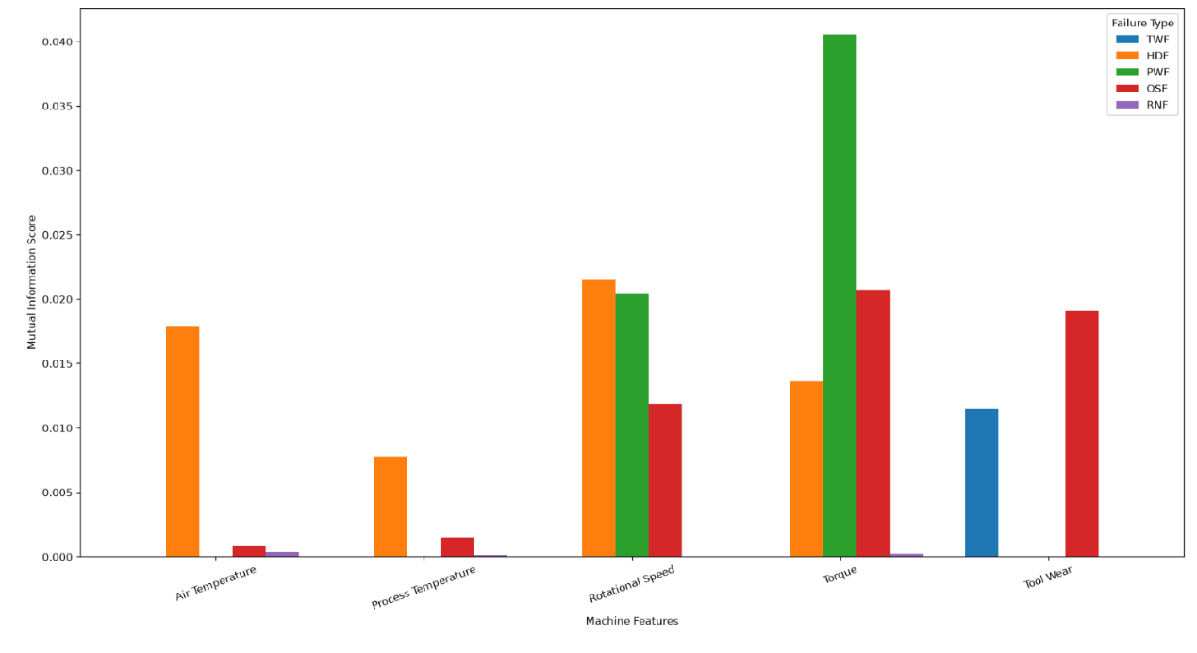
Feature Association with Individual Failure Types

Fig 3.6 Feature Association with Individual Failure Types
Figure 3.6 shows the association between the machine operating features and individual failure types using mutual information scores. Higher scores indicate a stronger relationship between a feature and a particular failure type. The results show that different failure types are associated with different machine parameters. Tool Wear shows a strong association with TWF, while temperature and rotational speed are more relevant to HDF. Torque and rotational speed show stronger associations with PWF, whereas Tool Wear and Torque are more relevant to OSF. RNF shows relatively weak associations with the measured machine parameters. This indicates that individual failure types are related to different combinations of operating conditions

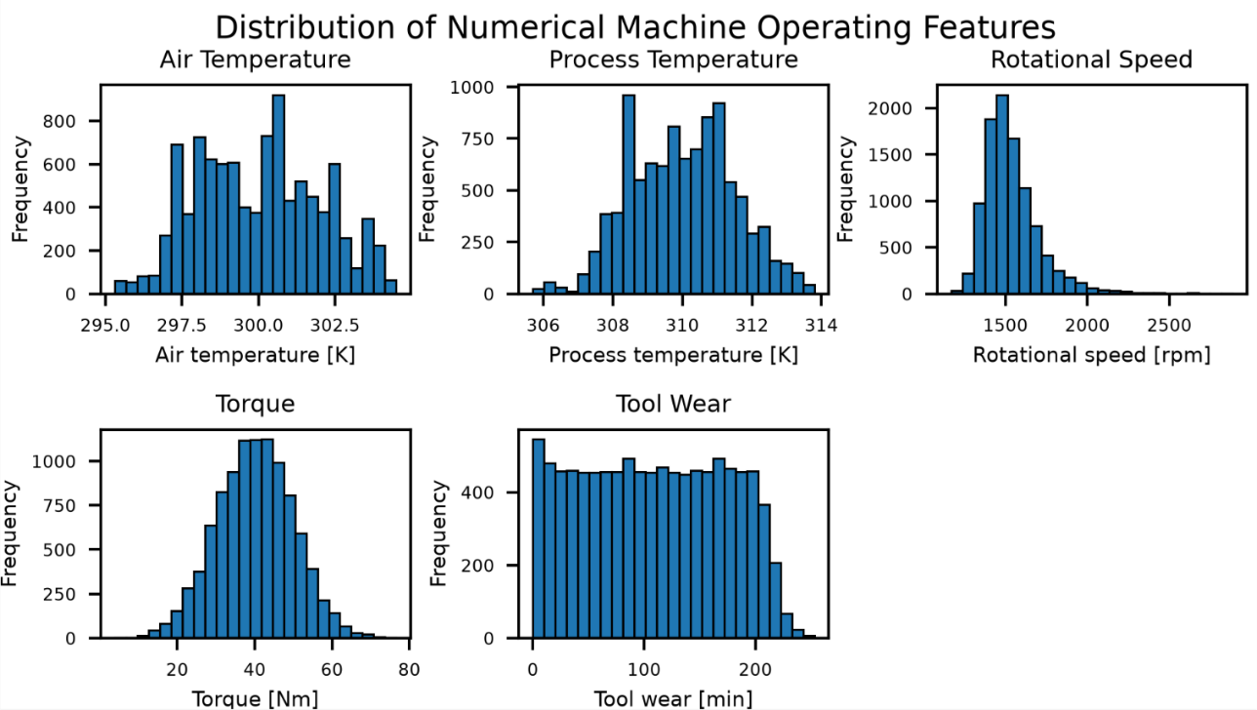
Distribution of Numerical Features

Figure 3.7: Visualization of Numeric Feature Distribution
The numerical features were visualized to understand their distributions and identify variations in the machine operating parameters. Figure 3.7 shows the distributions of Air Temperature, Process Temperature, Rotational Speed, Torque, and Tool Wear. The plots provide an overview of the range and distribution of each numerical feature before further analysis and model development.
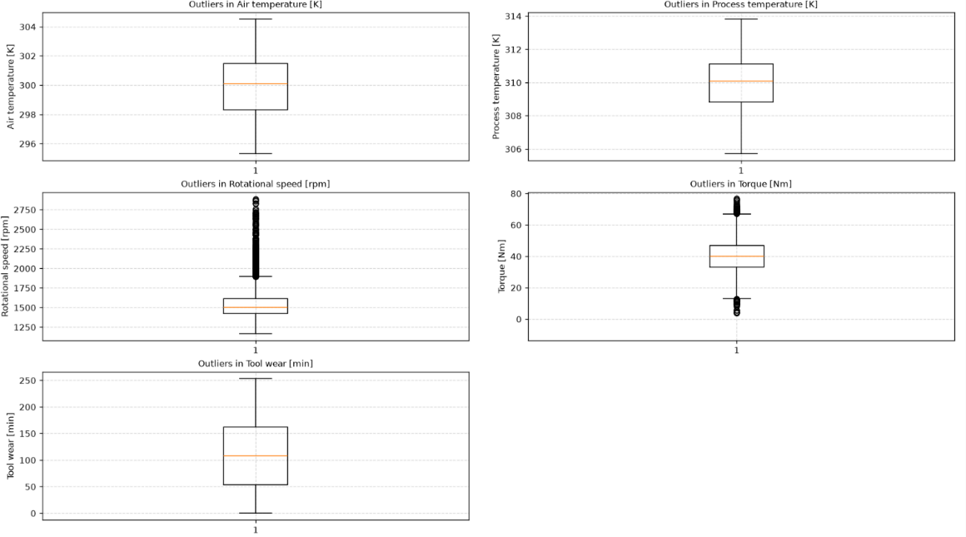
    - Outlier Visualization after Preprocessing
Figure 3.8: Outlier Visualization
Boxplots were generated for all numerical machine operating parameters to visualize the data distribution and identify potential outliers. The analysis showed that Air Temperature and Process Temperature have stable distributions with minimal outliers, while Rotational Speed and Torque contain genuine operational outliers resulting from varying machine operating conditions. Tool Wear exhibits a broad distribution corresponding to different stages of tool usage without unrealistic extreme values. These outliers were retained because they represent real industrial operating conditions rather than erroneous measurements. Overall, the boxplot visualization confirms the quality and consistency of the dataset while preserving meaningful operational variations essential for accurate machine learning-based predictive maintenance.

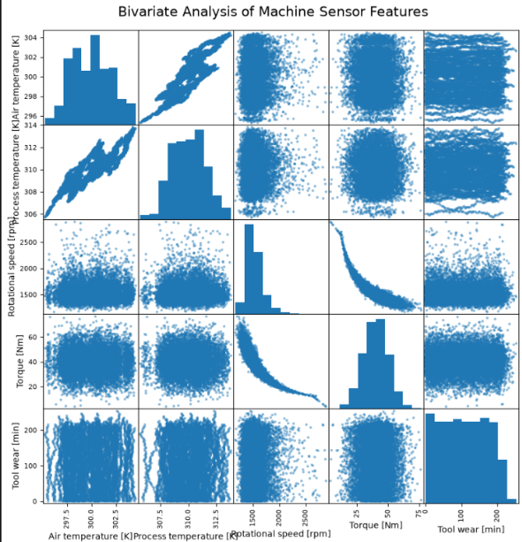
Bivariate Analysis

Figure 3.9: Bivariate Analysis of Machine Sensor Features
Bivariate analysis was performed to examine the relationships between pairs of numerical machine operating parameters. The analysis shows a strong positive relationship between Air Temperature and Process Temperature, indicating that both temperatures tend to increase together. A strong negative relationship is observed between Rotational Speed and Torque, meaning that torque generally decreases as rotational speed increases. The other feature pairs, including Tool Wear, show relatively weak or no clear linear relationships with the remaining parameters. Overall, the analysis helps identify important correlations between machine operating conditions.
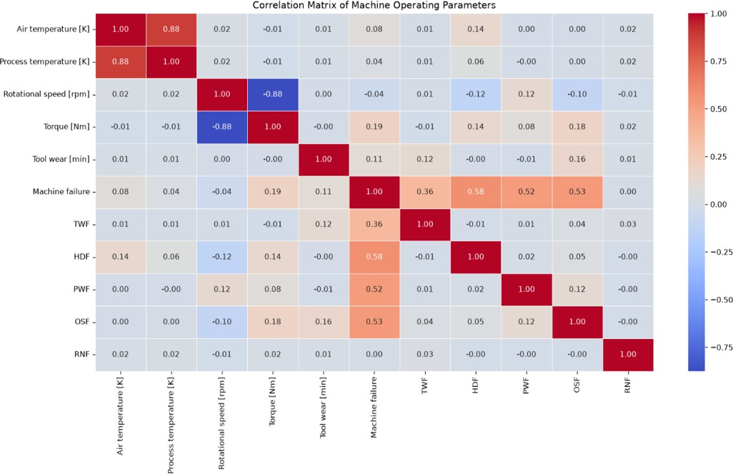
    - Correlation Matrix

Figure 3.10: Correlation Matrix of Machine Operating Parameters
Figure 3.10 presents the correlation matrix of the numerical machine operating parameters. The heatmap shows that Air Temperature and Process Temperature have a strong positive correlation (approximately 0.88), indicating that both parameters increase together during machine operation. Torque and Rotational Speed exhibit a moderate negative correlation (approximately -0.88), suggesting that an increase in rotational speed is generally associated with a decrease in torque. Tool Wear shows weak correlations with most operating parameters, indicating that it provides independent information. The target variable (Machine Failure) has only weak to moderate correlations with individual features, implying that machine failure depends on the combined effect of multiple operating parameters rather than a single feature. Overall, the absence of strong correlations among most predictor variables indicates low multicollinearity, making the selected features suitable for machine learning model development.

Analysis of Algorithm
This section presents a detailed analysis of the machine learning algorithms used in the pro-posed predictive maintenance system. The study includes the working principles, strengths, justification for selection, activity diagrams, and step-by-step workflow of each algorithm used for machine failure prediction.

Detailed Study Report of the Proposed Algorithm
      - Random Forest
Random Forest is an ensemble supervised machine learning algorithm that combines multiple Decision Trees for classification. Each tree is trained using different samples of the data and subsets of features, and the final prediction is determined through majority voting. In the proposed system, Random Forest predicts machine failure based on operating parameters such as temperature, rotational speed, torque, and tool wear. It is suitable for the system because machine failure may result from the combined effect of multiple parameters, while the dataset analysis indicates only weak to moderate individual correlations between the input variables and machine failure.

Important Parameters of Random Forest

Parameter | Purpose
n estimators | Number of decision trees in the forest
criterion | Criterion used to measure the quality of a split, such as Gini Impurity or Entropy
max depth | Maximum depth of each decision tree
max features | Number of features considered when searching for the best split
min samples split | Minimum number of samples required to split an internal node
min samples leaf | Minimum number of samples that must remain in a leaf node
class weight | Used to give greater importance to minority failure classes when required
Table 3.1: Important Parameters of Random Forest

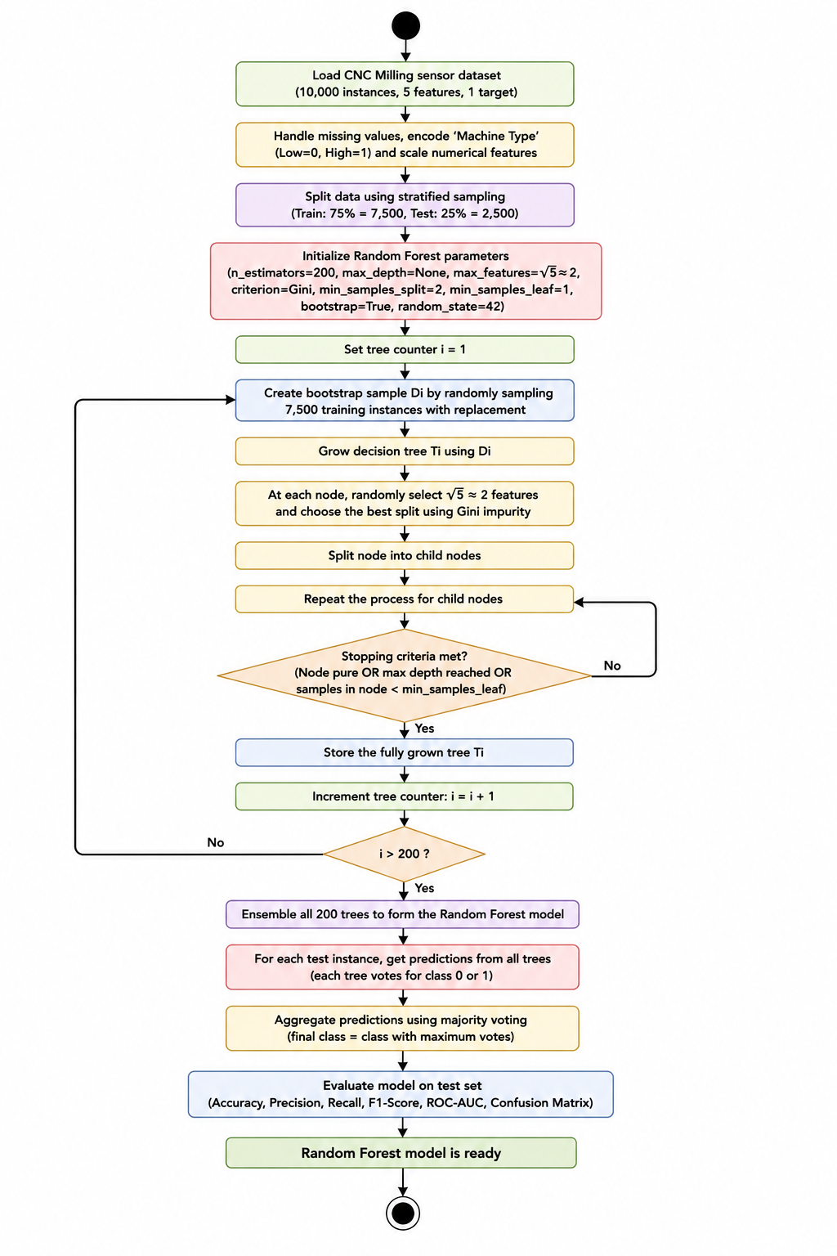
Figure 3.11: Activity Diagram of Random Forest

Working of Random Forest
Random Forest first creates multiple bootstrap samples from the training dataset, and a separate Decision Tree is trained using each sample. During the construction of every tree, only a randomly selected subset of features is considered when determining the best split at each node. For classification, split quality can be measured using criteria such as Gini Impurity or Entropy, and the split that produces the best reduction in impurity is selected. This process is repeated recursively until the stopping conditions are reached.
For a new machine record, each completed Decision Tree generates a class prediction based on the machine operating parameters. The predictions from all trees are then combined using majority voting to obtain the final machine failure prediction. The performance of the Random Forest model is evaluated using Accuracy, Precision, Recall, F1-Score, ROC-AUC, and Confusion Matrix.

Support Vector Machine
Support Vector Machine (SVM) is a supervised machine learning algorithm used for classification that finds an optimal decision boundary, called a hyperplane, to separate different classes with the maximum possible margin. In the proposed predictive maintenance system, SVM classifies machine operating conditions as normal or failure, and kernel functions can be used when the relationship between the input parameters and machine failure is not linearly separable.

Important Parameters of Support Vector Machine

Parameter | Purpose
C | Controls the trade-off between margin width and classification errors
kernel | Determines the mathematical function used to construct the decision boundary
gamma | Controls the influence of individual samples when using kernels such as RBF
degree | Determines the polynomial degree when the polynomial kernel is used
class weight | Can assign greater importance to minority classes in an imbalanced dataset
Table 3.2: Important Parameters of Support Vector Machine

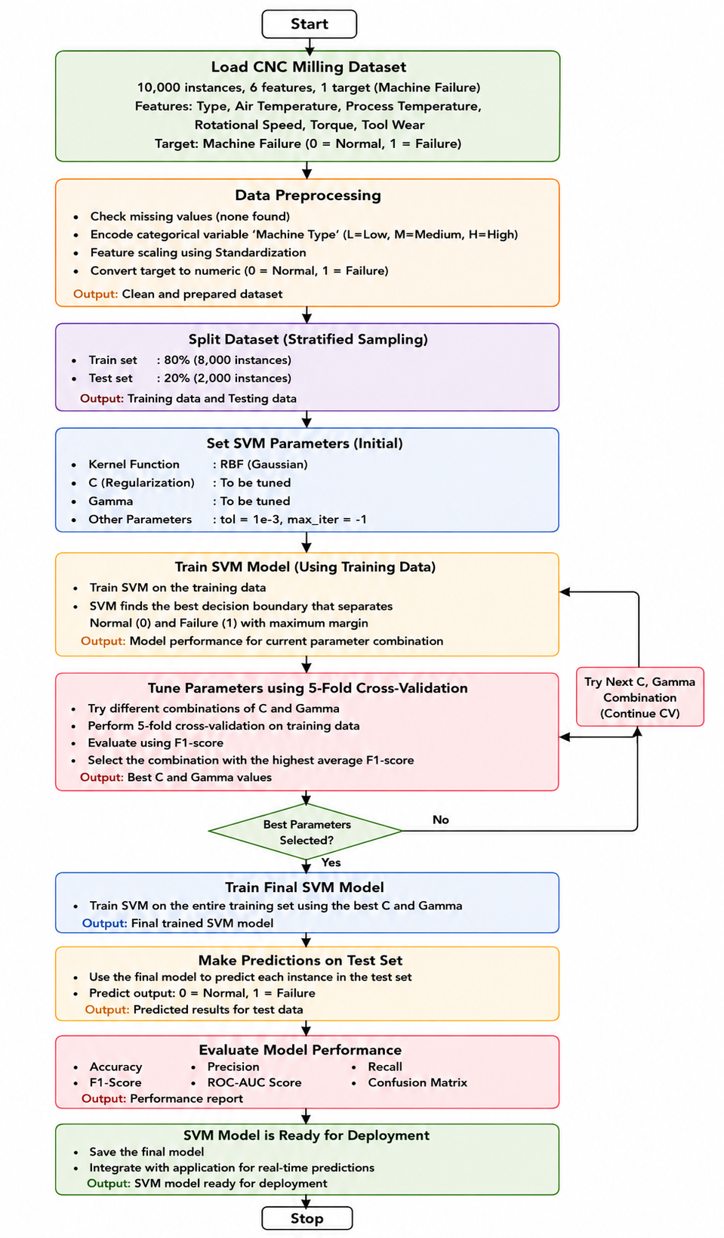
Figure 3.12: Activity Diagram of Support Vector Machine

Working of Support Vector Machine
The SVM algorithm first receives the preprocessed machine operating parameters and represents the training data as points in a multidimensional feature space. It then finds an optimal hyperplane that separates the normal and failure classes while maximizing the margin. The points closest to the boundary, called support vectors, determine its position. The C parameter controls the trade-off between maximizing the margin and correctly classifying training samples, while the kernel function determines how the model handles non-linear relationships. For non-linear kernels such as RBF, the gamma parameter controls the influence of individual training samples on the decision boundary. After training, new machine records are evaluated using the learned decision boundary and classified as normal or failure.

XGBoost (Extreme Gradient Boosting)
XGBoost is a supervised machine learning algorithm that builds an ensemble of decision trees sequentially, with each new tree learning to correct the errors made by the previous trees. In the proposed predictive maintenance system, the model uses machine operating parameters to predict whether a machine is likely to fail. Important parameters such as the number of estimators, learning rate, maximum tree depth, subsampling, and regularization settings control the model training process. The predictions from all trees are combined to produce the final machine failure prediction.
Important Parameters of XGBoost
Parameter | Purpose
n estimators | Number of boosting trees
learning rate | Controls the contribution of each new tree
max depth | Maximum depth of each tree
min child weight | Controls the minimum amount of data required for further splitting
gamma | Minimum loss reduction required to create a split
subsample | Fraction of training samples used for each tree
colsample bytree | Fraction of features used for each tree
reg alpha | L1 regularization term
reg lambda | L2 regularization term
Table 3.3: Important Parameters of XGBoost
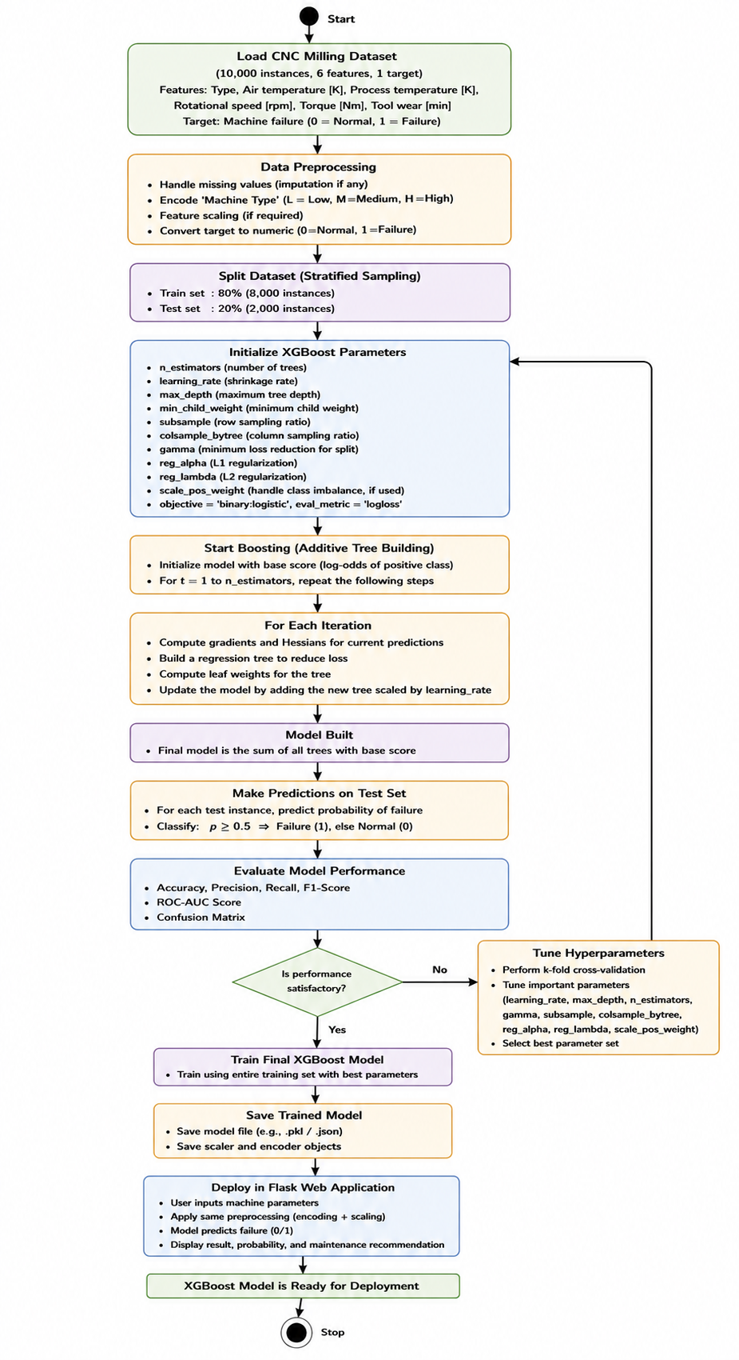

Figure 3.13: Activity Diagram of XGBoost

Working of XGBoost
XGBoost begins with an initial prediction for the training samples and calculates the prediction errors. A new decision tree is then constructed to learn these errors, and its prediction is added to the existing model using the learning rate, which controls how much each new tree contributes to the overall model. This process is repeated for multiple boosting rounds, where the number of estimators determines the total number of trees built. During tree construction, XGBoost evaluates possible feature splits using a split gain measure and selects splits that improve the model. The maximum depth controls the complexity of each tree, while subsampling uses a portion of the training data for each tree. Regularization parameters are also applied to control model complexity and reduce overfitting. The predictions from all sequentially built trees are combined to produce the final machine failure prediction.

Project Pipeline
The project pipeline illustrates the complete workflow of the proposed Predictive Maintenance System for CNC milling machines. It begins with collecting the machine operational dataset and proceeds through preprocessing, model development, evaluation, and prediction generation. Each stage plays an important role in ensuring accurate and reliable machine failure prediction.

Project Pipeline Diagram with Explanation
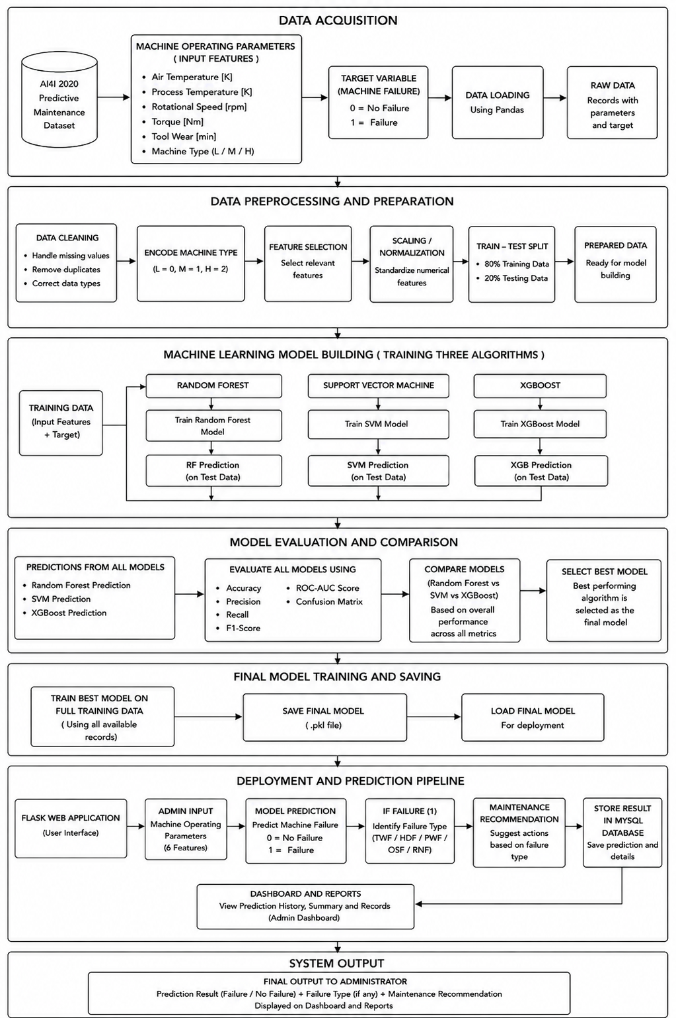

Figure 3.14: Project workflow
Data Acquisition Phase
The pipeline begins with the AI4I 2020 Predictive Maintenance Dataset, which contains machine operating parameters and failure information. The input features include Air Temperature, Process Temperature, Rotational Speed, Torque, Tool Wear, and Machine Type (Product Type). The target variable is Machine Failure, where 0 represents No Failure and 1 represents Failure. The dataset is loaded into the system using Pandas, producing the raw data containing the required machine parameters and target information for further processing.
Data Preprocessing and Preparation Phase
The raw dataset is prepared for machine learning through a series of preprocessing steps. Data cleaning is performed by checking for missing values, removing unnecessary columns such as the UDI, handling duplicate records where required, and ensuring that the data types are appropriate. The categorical Machine Type/Product Type variable is converted into numerical form using Label Encoding, where the categories are represented numerically. Relevant features are then selected for model development, followed by feature scaling/standardization of the numerical variables to ensure that the features are on a comparable scale. Finally, the prepared dataset is divided into 80% training data and 20% testing data, producing the data required for model building and evaluation.
Machine Learning Model Building Phase
The training dataset is used to develop three machine learning models: Random Forest, Support Vector Machine (SVM), and XGBoost. Each algorithm is trained independently using the selected input features and the Machine Failure target variable. After training, each model generates predictions on the test dataset. This allows the performance of Random Forest, SVM, and XGBoost to be evaluated and compared using the same unseen test data.
Model Evaluation and Comparison Phase
The predictions generated by all three machine learning models are evaluated using Accuracy, Precision, Recall, F1-Score, ROC-AUC Score, and Confusion Matrix. The performance of Random Forest, SVM, and XGBoost is compared across these evaluation metrics. Based on the overall performance, the best-performing model is selected as the final model for the predictive maintenance system. This comparison helps identify the algorithm that provides the most suitable machine failure prediction performance for the given dataset.
Final Model Training and Saving Phase
After selecting the best-performing algorithm, the selected model is retrained using the full available training data so that it can learn from all records available for model development. The final trained model is then saved as a .pkl file, allowing the trained model to be reused without performing the complete training process again. The saved model is subsequently loaded by the application during deployment for making predictions on new machine operating data.
Deployment and Prediction Phase
The final trained model is integrated into a Flask-based web application that provides the user interface for the predictive maintenance system. The administrator enters the current machine operating parameters through the application. These input values are processed using the same preprocessing steps applied during model development and are provided to the saved machine learning model. The model predicts whether the machine is in a normal condition or failure condition. If a failure is predicted, the system identifies the likely failure type, such as TWF, HDF, PWF, OSF, or RNF, and provides a suitable maintenance recommendation based on the predicted condition. The prediction result and relevant details are stored in the MySQL database for future reference.

Feasibility Analysis

Technical Feasibility
The proposed system is developed using widely adopted technologies such as Python, Flask, MySQL, and machine learning libraries including Scikit-learn and XGBoost. The AI4I 2020 Predictive Maintenance dataset provides sufficient machine operational data for training and evaluating predictive models. The system is implemented using standard computing resources without requiring specialized hardware or industrial IoT devices. The selected machine learning algorithms—Random Forest, Support Vector Machine (SVM), and XGBoost—are well suited for classification tasks and can accurately predict machine failures. The system is therefore technically feasible and suitable for practical deployment.

Economic Feasibility
The proposed system is economically feasible because it utilizes open-source software and freely available development tools. Python, Flask, MySQL, Scikit-learn, XGBoost, and Visual Studio Code are available without licensing costs, significantly reducing development expenses. The AI4I 2020 Predictive Maintenance dataset is publicly available for research purposes, eliminating data acquisition costs. Since the application runs on a standard personal computer, no additional investment in specialized hardware is required.

Operational Feasibility
The proposed system is operationally feasible because it provides a simple and user-friendly web interface that enables users to enter machine operating parameters and obtain prediction results efficiently. The system predicts machine failures, identifies the probable failure type, and provides maintenance recommendations to support informed decision-making. The integration of a MySQL database ensures efficient storage and retrieval of machine data and prediction records.

System Environment
The system environment defines the software and hardware requirements necessary for the development, training, deployment, and execution of the proposed Machine Learning-Based Predictive Maintenance System. The system is developed using Python-based technologies and machine learning libraries, while the Flask framework and MySQL database provide an efficient platform for deploying the predictive maintenance application.

Software Environment
The software tools and technologies used for developing the proposed system are presented in Table 3.4.
Software | Purpose
Windows 11 | Operating System
Python 3.x | Programming Language
Flask | Web Application Framework
MySQL | Database Management System
Scikit-learn | Machine Learning Library
XGBoost | Gradient Boosting Library
Pandas | Data Manipulation
NumPy | Numerical Computing
Matplotlib | Data Visualization
Seaborn | Statistical Visualization
Visual Studio Code | Integrated Development Environment (IDE)
Table 3.4: Software Requirements

Hardware Environment
The proposed system is implemented and tested on a standard personal computer without requiring specialized hardware, as shown in Table 3.5.
Hardware | Specification
Processor | Intel Core i7 Processor or equivalent
RAM | 16 GB or higher
Storage | 512 GB SSD or higher
Internet | Required for downloading libraries and project dependencies
Table 3.5: Hardware Requirements

System Design

4.1 Models Building
The model building phase of the proposed Predictive Maintenance System focuses on developing machine learning models for predicting machine failures based on operating parameters of industrial machines. The AI4I 2020 Predictive Maintenance Dataset is used for developing and evaluating the proposed models. The dataset contains machine operating parameters including product type, air temperature, process temperature, rotational speed, torque, and tool wear.
The overall machine failure prediction is formulated as a binary classification problem in which the model determines whether a given machine operating condition corresponds to a failure or a normal condition. In addition to overall machine failure prediction, separate classification models are developed to identify specific failure types, namely Heat Dissipation Failure (HDF), Power Failure (PWF), and Overstrain Failure (OSF).
Random Forest, Support Vector Machine (SVM), and XGBoost classification algorithms are considered for model development. The models are trained using the training dataset and evaluated using the testing dataset. The performance of the developed models is assessed using Accuracy, Precision, Recall, F1-Score, ROC-AUC, and Confusion Matrix.
    - Implementation Code
The implementation of the predictive maintenance models is carried out using Python. Pandas and NumPy are used for data handling and preprocessing, while Scikit-learn is used for implementing the Random Forest and Support Vector Machine algorithms and for calculating the evaluation metrics. The XGBoost library is used for implementing the XGBoost classification model.
from xgboost import XGBClassifier
X_train_xgb = X_train.copy()
X_test_xgb = X_test.copy()

X_train_xgb.columns = [
col.replace("[", "_").replace("]", "").replace("<", "_")
for col in X_train_xgb.columns
]

X_test_xgb.columns = [
col.replace("[", "_").replace("]", "").replace("<", "_")
for col in X_test_xgb.columns
]
xgb_model = XGBClassifier(
random_state=42
)

xgb_model.fit(X_train_xgb, y_train)
y_pred_xgb = xgb_model.predict(X_test_xgb)

4.1.2 Model Planning (Training/Testing Split of the Dataset)
The model planning phase involves dividing the preprocessed dataset into training and testing subsets. The dataset is divided using an 80:20 ratio, where 80 percent of the observations are allocated for model training and the remaining 20 percent are reserved for testing.
The training dataset is used to enable the machine learning algorithms to learn the relationship between the machine operating parameters and the corresponding failure conditions. The testing dataset is kept separate from the training process and is used to evaluate the performance of the trained models on previously unseen observations.
The dataset is divided using the train_test_split() function provided by the Scikit-learn library. A fixed random state of 42 is used to ensure reproducibility of the experimental results.
X_train, X_test, y_train, y_test = train_test_split(
X, y, test_size=0.20,random_state=42, stratify=y)
Stratified splitting is used for the classification task to maintain a similar distribution of the target classes in both the training and testing datasets. The same model planning procedure is applied to the individual HDF, PWF, and OSF failure classification models using their respective target variables.
4.1.3 Training
The training phase involves developing machine learning models using the training dataset prepared during the model planning stage. The selected machine operating parameters are provided as input variables and the corresponding failure condition is used as the target variable.
Three classification algorithms, namely Random Forest, Support Vector Machine, and XGBoost, are implemented and trained independently. Random Forest constructs multiple decision trees using different subsets of the training data and combines their predictions to obtain the final classification. Support Vector Machine constructs a decision boundary that separates the different classes based on the input feature space. XGBoost constructs a sequence of decision trees in which subsequent trees attempt to improve the errors produced by previous trees.
The Random Forest classifier is trained using the following implementation.
rf_model = RandomForestClassifier(
n_estimators=300, random_state=42, class_weight="balanced")
rf_model.fit( X_train, y_train)

The Support Vector Machine classifier is trained using the training data as follows.
scaler = StandardScaler()
X_train_scaled = scaler.fit_transform(X_train)
X_test_scaled = scaler.transform(X_test)
svm_model = SVC( kernel="rbf", probability=True, class_weight="balanced", random_state=42)
svm_model.fit( X_train_scaled, y_train)
XGBoost classifier is trained using the training dataset.
scale_pos_weight = (
y_train.value_counts()[0] /
y_train.value_counts()[1]
)
print("Scale Pos Weight:",
round(scale_pos_weight, 4))

xgb_model = XGBClassifier(
n_estimators=300,
learning_rate=0.05,
max_depth=5,
min_child_weight=1,
subsample=0.8,
colsample_bytree=0.8,
gamma=0,
reg_alpha=0.1,
reg_lambda=1.0,
scale_pos_weight=scale_pos_weight,
objective="binary:logistic",
eval_metric="logloss",
random_state=42
)

xgb_model.fit(
X_train,
y_train
)
print("XGBoost model trained successfully.")
The same training methodology is followed for the prediction of Heat Dissipation Failure, Power Failure, and Overstrain Failure. Each failure type is treated as an independent binary classification problem so that the model can determine whether the particular failure condition is present or absent.
4.1.4 Testing
The testing phase evaluates the performance of the trained machine learning models using the testing dataset. The testing dataset consists of observations that were not used during the training process, allowing the generalization capability of the developed models to be assessed.
Predictions are generated by providing the testing features to the trained models.
y_pred = model.predict(X_test)
The performance of the classification models is evaluated using Accuracy, Precision, Recall, F1-Score, ROC-AUC, and Confusion Matrix. Accuracy measures the proportion of correctly classified observations among all test observations. Precision measures the proportion of correctly predicted failure cases among the observations classified as failures. Recall measures the ability of the model to correctly identify actual failure cases. F1-Score provides a balance between Precision and Recall. ROC-AUC measures the ability of the model to distinguish between the positive and negative classes at different classification thresholds.
The confusion matrix provides a detailed representation of the classification results by identifying true positive, true negative, false positive, and false negative predictions.
5. RESULTS AND DISCUSSION
5.1 Comparison of Models
Three machine learning algorithms, namely Random Forest, Support Vector Machine (SVM), and XGBoost, were trained to predict machine failure using the preprocessed AI4I 2020 Predictive Maintenance Dataset. The performance of the models was evaluated using Accuracy, Precision, Recall, F1-Score, and ROC-AUC.
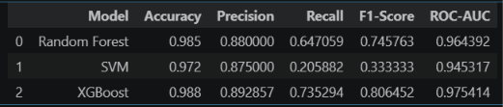
For the current finalized implementation, XGBoost was used for the overall machine failure prediction and for the HDF, PWF, and OSF failure-type prediction models. The individual failure-type models were developed independently because the occurrence and distribution of each failure type differ within the dataset.
The finalized test-set results obtained from the developed XGBoost models are presented below.
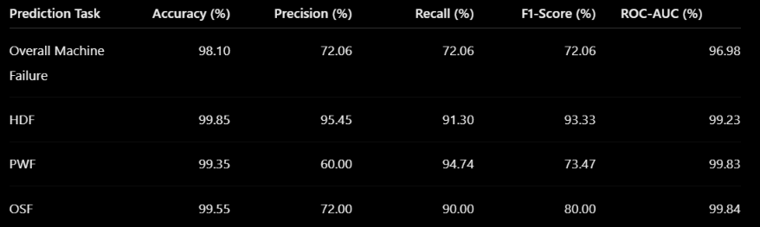
The results demonstrate that the developed models achieve high overall classification accuracy. However, because the dataset is highly imbalanced, Accuracy alone does not provide a complete representation of failure-detection performance. Therefore, Precision, Recall, F1-Score and ROC-AUC are considered along with Accuracy.
5.2 Evaluation Metrics
The performance of the developed models was evaluated using Accuracy, Precision, Recall, F1-Score, and ROC-AUC.
The overall Machine Failure model achieved an Accuracy of 98.10%, with Precision, Recall and F1-Score of 72.06%. The ROC-AUC value of 96.98% indicates that the model provides good discrimination between normal and failure conditions.
For Heat Dissipation Failure, the model achieved an Accuracy of 99.85%, Precision of 95.45%, Recall of 91.30%, and F1-Score of 93.33%. The ROC-AUC of 99.23% indicates strong class discrimination.
The Power Failure model achieved an Accuracy of 99.35%. Its Precision was 60.00%, while Recall reached 94.74%, resulting in an F1-Score of 73.47%. The ROC-AUC value of 99.83% indicates strong discrimination between PWF and non-PWF conditions.
For Overstrain Failure, the model achieved an Accuracy of 99.55%, Precision of 72.00%, Recall of 90.00%, and F1-Score of 80.00%. The ROC-AUC value was 99.84%, indicating strong classification capability.
The results show that the models are particularly effective in identifying actual failure cases for HDF, PWF and OSF, as reflected by their relatively high Recall values.
5.3 Confusion Matrix
The model correctly classified 1,913 normal instances and 49 failure instances. It incorrectly classified 19 normal instances as failures and 19 actual failure instances as normal.The resulting Accuracy is 98.10%, while the Precision, Recall and F1-Score are each approximately 72.06%.
Heat Dissipation Failure (HDF) resulted in an Accuracy of 99.85%, Precision of 95.45%, Recall of 91.30%, and F1-Score of 93.33%.
Power Failure (PWF) achieved an Accuracy of 99.35%, Precision of 60.00%, Recall of 94.74%, and F1-Score of 73.47%.
Overstrain Failure (OSF) resulting Accuracy was 99.55%, with Precision of 72.00%, Recall of 90.00%, F1-Score of 80.00%, and ROC-AUC of 99.84%.
5.4 Relevant Metrics Calculated from the Confusion Matrix
In addition to the standard classification metrics, the confusion matrices provide additional measures for evaluating the ability of the models to correctly identify normal and failure conditions.
Overall Machine Failure
The overall model correctly classified 1,962 out of 2,000 test observations. The True Negative Rate, also referred to as Specificity, was approximately 99.02%, indicating that most normal machine conditions were correctly identified. The False Negative Rate was approximately 27.94%, corresponding to the failure cases that were not detected by the model.
Heat Dissipation Failure
The HDF model achieved a Specificity of approximately 99.95% and a False Negative Rate of approximately 8.70%. The low number of false positives and false negatives indicates consistent classification performance for HDF.
Power Failure
The PWF model achieved a Specificity of approximately 99.39% and a False Negative Rate of approximately 5.26%. The relatively high Recall indicates that the model successfully identifies most actual PWF cases. However, the number of false-positive predictions results in a lower Precision of 60.00%.
Overstrain Failure
The OSF model achieved a Specificity of approximately 99.65% and a False Negative Rate of 10.00%. The model successfully identified 90% of the actual OSF cases while maintaining a high rate of correct classification for non-OSF observations.
5.5 Prediction Statistics of Unseen Data
The testing stage was performed using an unseen test dataset containing 2,000 observations for each classification task based on the 80:20 train-test split.
For the overall Machine Failure model, the test dataset contained 68 actual failure cases and 1,932 normal cases. The model predicted 68 observations as failures and 1,932 observations as normal. Among these predictions, 49 failure cases were correctly identified and 19 failure cases were incorrectly classified as normal.
For HDF, the test dataset contained 23 actual HDF cases and 1,977 non-HDF cases. The model correctly identified 21 HDF cases and missed 2 cases. It generated one false-positive HDF prediction.
For PWF, the test dataset contained 19 actual PWF cases and 1,981 non-PWF cases. The model correctly identified 18 PWF cases and missed one case. Twelve non-PWF observations were classified as PWF.
For OSF, the test dataset contained 20 actual OSF cases and 1,980 non-OSF cases. The model correctly identified 18 OSF cases and missed two cases. Seven non-OSF observations were classified as OSF.
5.6 Discussion of Findings
The results demonstrate that the developed XGBoost models provide effective predictive performance for overall machine failure and the considered failure types, namely HDF, PWF, and OSF. The Overall Machine Failure model achieved an accuracy of 98.10% and an ROC-AUC of 96.98%, indicating that the model can distinguish between normal operating conditions and machine failure conditions with high overall effectiveness. Among the individual failure-type models, HDF achieved an accuracy of 99.85% and an F1-score of 93.33%, showing a strong balance between precision and recall. The PWF model achieved a recall of 94.74%, indicating that it successfully identified a high proportion of actual power-related failure cases, although its precision of 60.00% shows that some predicted PWF cases were false positives. The OSF model achieved an accuracy of 99.55%, recall of 90.00%, and F1-score of 80.00%, demonstrating good capability in detecting actual overload-related failure cases. The high ROC-AUC values obtained across all models, ranging from 96.98% to 99.84%, further indicate strong discrimination between failure and non-failure conditions. Overall, the findings show that the developed models can serve as a useful machine-learning-based decision-support component for predictive maintenance by identifying potential machine failures and specific failure types from the available operational parameters.

